**React- Components State Props**

Q.1React-Component

ANS -A component is a self-contained piece of code that defines a part of a user interface. Components can be reused and composed to build complex UIs. In React, components can be either class components or functional components.



Q.2 React-State

ANS - State is an object that stores data that can change over time within a component. When the state changes, the component re-renders and updates the UI to reflect the new state. State can only be updated using the **`setState`** method and should not be modified directly.

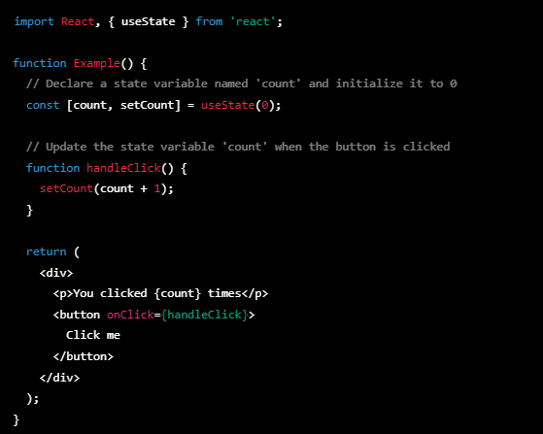

Q.3 React-Props

ANS -In React, `**props`** (short for properties) are used to pass data between components. They allow a parent component to pass data down to its child components, which can then use that data to render their output.

